

**Charles Olbon School**

**Ms. Tonti**

**Kindergarten**

**Room 4**

**2017-2018**

September 2017

Dear Parents / Guardians,

Welcome to Charles Olbon’s “Back to School Night.” My name is Ms. Tonti and I am your child’s kindergarten teacher.

I am a lifelong resident of Woodland Park. As a child, I attended Charles Olbon and Memorial School. I graduated Passaic Valley High School and then, attended Caldwell College. All of my field work was completed in the district of Woodland Park. Upon graduating college, I was hired within this district. The beginning of September marked my eighteenth year of teaching, here, in Woodland Park. It is wonderful to give back to my community, what I was given as a child, a great education that was provided by dedicated teachers. I will continue to carry out that tradition of dedication. I am very lucky to say that I LOVE my career.

Thank you for coming to tonight’s event. It is important that you are involved in your child’s education, and being here tonight, is your first step. I appreciate any and all efforts you make to support your child through their educational experiences.

The following is a list of notices that you received and will receive throughout this school year:

1. Summer Introduction Note and #s 2-5 were included in the Envelope
2. Going Home Procedures
3. Helpful Information
4. Website Directive
5. Description of General Items
6. General Items Summary
7. Nap Time Memo
8. Kindergarten Expectancy Inquiry and “All About Me” / Survey
9. Folders Description and Explanation

see back

1. Class Procedures / Subject Overview
2. Class Schedule of ALL Subjects
3. Special Subjects Schedule
4. Class Roster
5. Homework Policy
6. Homework Completion Directions
7. Responsibility/Due Date Obligations
8. Sight Words Directive,
9. Pre-Decodable and Decodable Reading Books Notice,
10. Phonics/Reading Strategies,
11. Reading Techniques,
12. Guided Reading Tips.

**Take notes on the following topics, if needed or interested.** I will review the daily schedule of **subjects** and give you a **general overview** of some of the material being covered. I will discuss **homework** procedures. I will also talk about **incentive** procedures in the classroom. Hold all questions until the end of this session.

***Look for any further information on projects and / or events in the classroom and / or school in your child’s NOTICE (yellow) FOLDER and on our school’s website (www.wpschools.org – click on Student Homework, Charles Olbon, Teacher’s Name).***

Please be advised that there are set dates for Parent / Teacher Conferences. If you would like a conference meeting set aside from the school’s dates, please contact me to make an appointment: **write a *note***, **call the school *(973) 317 – 7730***, or **send an e-mail** to [***ctonti@wpschools.org***](mailto:ctonti@wpschools.org). Please understand that I can not hold conferences without an appointment nor at public, community functions such HSA meetings, Board Meetings, Sporting Events, etc.

** Visit the **district website** **DAILY**: go to [**www.wpschools.org**](http://www.wpschools.org), click on **Schools** – choose **Charles Olbon**, click on **Faculty Pages** – go under the letter “**T**” – choose **Tonti, Claudia**, then, review **EACH TOPIC** located on the **left-hand side**.

***Thank you for your sincere cooperation and assistance in making the 2017-2018, school year a great success for your child, my student.***

Sincerely, **Ms. Tonti**

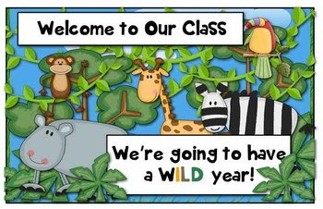

**Ms. Tonti**

**Charles Olbon School**

**Kindergarten**

**Room 4**

August 2017

Dear Parents / Guardians and Kindergarteners,

I hope that you had a great summer. Now, summer is almost over and school will

soon begin. ***I can not wait to meet you!*** I have been working hard getting our classroom set

up just right! On the first day of school, I would like you to wear this nametag. Our whole

class will have them and so will I. We will all be able to see each other this way. I would also

like you to wear a great big **smile** on your face! **We will have a great day!**

Parents / Guardians, I need you to tell me whether your child is taking the bus home,

going to the after school program, or being picked up and who will be picking up your child. If

your child is eligible to take the bus, **but** will **NOT** be taking it in the afternoon, you **MUST**

**write a note saying so**. Please be sure to tell me this the whole first week and afterwards **ONLY**

if the routine changes. Please use and place the correct attached symbols in a sealed, labeled

(your child’s name) envelope. I can help reassure the children when I know what they are doing.

 The children will be dismissed at **3:28 pm** on **Tuesday**, **September 6, 2016**.

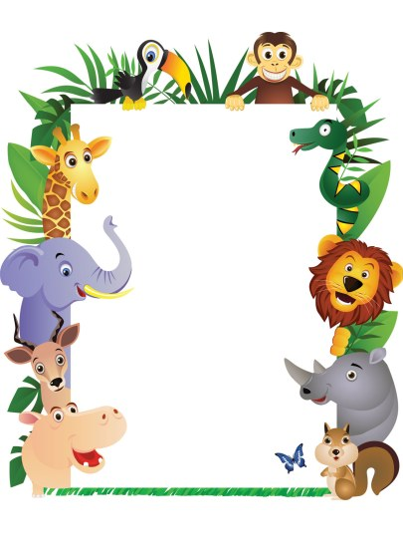***I am looking forward to a great year! See you soon!!!!***

Your Teacher,

Ms. Tonti

**PARENTS/GUARDIANS: FILL IN, *CUT OUT*, & SEND TO SCHOOL ON SEPTEMBER 6, 2017, WEDNESDAY:**

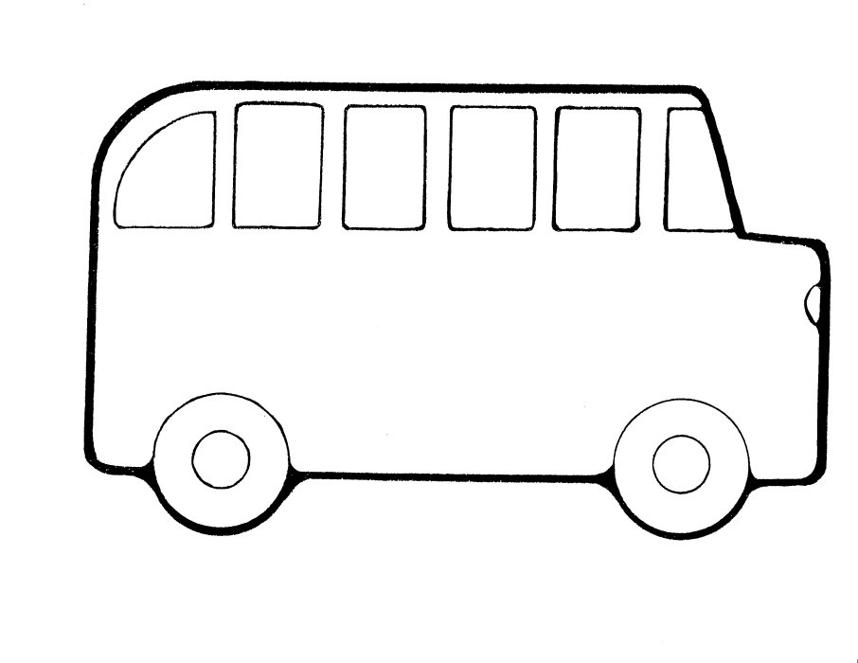**Buses-Write your child’s Name, the Bus #, and Use the Dated Buses that *apply* to your child.**

**Charles Olbon School Bus # _______**

**Sept. 6, 2017 –Wednesday, 3:28 PM Dismissal**

**Child’s Name: _____________________________**



**Charles Olbon School Bus # _______**

**Sept. 7, 2017 –Thursday, 3:28 PM Dismissal**

**Child’s Name: _____________________________**



**Charles Olbon School Bus # _______**

**Sept. 8, 2017 –Friday, 3:28 PM Dismissal**

**Child’s Name: _____________________________**

**Sept. 11 & on, 2017 –Monday & on YES or NO**

**PARENTS/GUARDIANS: FILL IN, *CUT OUT*, & SEND TO SCHOOL ON SEPTEMBER 6, 2017, WEDNESDAY:**

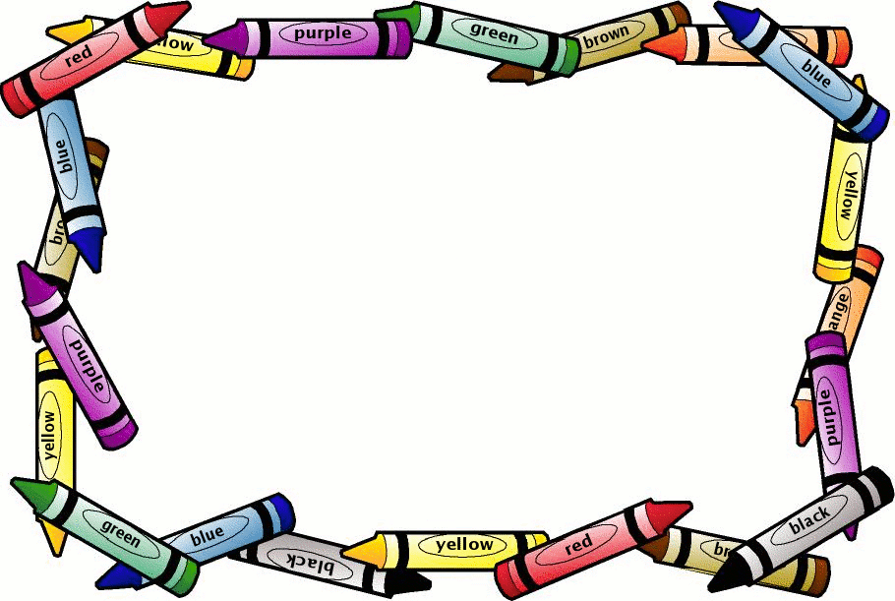**At-Ease (Aftercare Program)- Write your child’s Name and the Date(s) and Day(s) that *apply* to your child. Aftercare is only available to those who have signed up and properly completed all paper work. If not and you are interested, you must contact the Main Office for more information.**

**Charles Olbon School**

**At-Ease (Aftercare Program)**

**DATES: Sept._______________________**

**DAYS of the Week: __________________ ___________________________________**

**Child’s Name: ______________________**



**Charles Olbon School**

**At-Ease (Aftercare Program)**

**DATES: Sept._______________________**

**DAYS of the Week: __________________ ___________________________________**

**Child’s Name: ______________________**



**Charles Olbon School**

**At-Ease (Aftercare Program)**

**DATES: ____________________________**

**DAYS of the Week: __________________ ___________________________________**

**Child’s Name: ______________________**

**PARENTS/GUARDIANS: FILL IN, *CUT OUT*, & SEND TO SCHOOL ON SEPTEMBER 6, 2017, WEDNESDAY:**

**Pick-ups - Write your child’s Name and the Date(s) and Day(s) that *apply* to your child.**

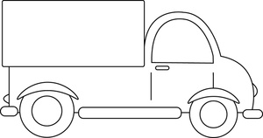**Charles Olbon School**

**Who is picking up? Relation?**

**________________________________**

**DATE(S): _______________________**

**DAY(S) of the week: ______________**

**Child’s Name:**

**Charles Olbon School**

**Who is picking up? Relation?**

**________________________________**

**DATE(S): _______________________**

**DAY(S) of the week: ______________**

**Child’s Name:**



**Charles Olbon School**

**Who is picking up? Relation?**

**________________________________**

**DATE(S): _______________________**

**DAY(S) of the week: ______________**

**Child’s Name:**

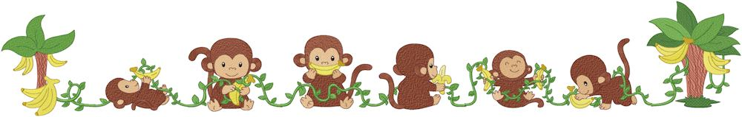**Helpful Information – K-Tonti**

**Please fill out this form so I have it on file in my classroom. Thank You! This information will be**

**kept confidential. (Please feel free to use the back for more writing space.)**

**Child’s Name: _____________________________________________**

**Mother’s Name: ___________________________________________**

**Father’s Name: ____________________________________________**

**Address: ______________________________________________, Woodland Park, NJ 07424**

**Home Phone: ______________________________________________**

**Best Way to reach a parent/guardian: - Email? Home? Cell? Work? –**

**(Ex: John Smith 973-589-6312 – cell #): ___________________________________________**

**_____________________________________________________________________________**

**Any problems your child may have? Fears? _______________________________________**

**____________________________________________________________________________**

**Any medical issues? Wear glasses? Bladder trouble? _______________________________**

**______________________________________________________________________________**

**Any Custody, family matters you may want me to know? ____________________________**

**______________________________________________________________________________**



**Helpful Information – K-Tonti**

**Please fill out this form so I have it on file in my classroom. Thank You! This information will be**

**kept confidential. (Please feel free to use the back for more writing space.)**

**Child’s Name: _____________________________________________**

**Mother’s Name: ___________________________________________**

**Father’s Name: ____________________________________________**

**Address: ______________________________________________, Woodland Park, NJ 07424**

**Home Phone: ______________________________________________**

**Best Way to reach a parent/guardian: - Email? Home? Cell? Work? –**

**(Ex: John Smith 973-589-6312 – cell #): ___________________________________________**

**_____________________________________________________________________________**

**Any problems your child may have? Fears? _______________________________________**

**____________________________________________________________________________**

**Any medical issues? Wear glasses? Bladder trouble? _______________________________**

**______________________________________________________________________________**

**Any Custody, family matters you may want me to know? ____________________________**

 **______________________________________________________________________________**

**Charles Olbon School**

**Ms. Tonti**

**Kindergarten**

**Room 4**

**2017-2018**

** Visit the **district website** **DAILY**: go to [**www.wpschools.org**](http://www.wpschools.org), click on **Schools** – choose **Charles Olbon**, click on **Faculty Pages** – go under the letter “**T**” – choose **Tonti, Claudia**, then, review **EACH TOPIC** located on the **left-hand side**.

**Charles Olbon School**

**Ms. Tonti**

**Kindergarten**

**Room 4**

**2017-2018**

** Visit the **district website** **DAILY**: go to [**www.wpschools.org**](http://www.wpschools.org), click on **Schools** – choose **Charles Olbon**, click on **Faculty Pages** – go under the letter “**T**” – choose **Tonti, Claudia**, then, review **EACH TOPIC** located on the **left-hand side**.

**Ms. Tonti**

**Charles Olbon School**

**Kindergarten**

**Room 4**



Snack time is every day at approximately 10:00 am or 1:30 pm (depending on lunch time). A **nutritious snack** all ready prepared to eat needs to be provided by parent/guardian. Water is our snack drink (**NO juices, soda, etc.**). Classroom closets are warm in September so please have children eat perishable foods (yogurts) at snack time. **All students must bring their own snacks**. **Snacks are NOT provided for your child through the breakfast and/or lunch program.** ***If school is dismissed at 1:20 pm, PLEASE be sure to send your child with a larger snack and a drink (permitted on half days) and no lunch.***

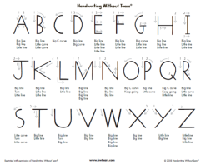

It would be helpful for you to encourage your child to **print**. We will work on **proper letter formation** at school and please follow at home. You will receive a packet from the implemented handwriting program. This will illustrate the proper strokes for printing.

Mary Smith K-To School Store

**Label** everything your child brings to school: jackets, hats, lunch boxes, book bags, etc. Please – **no toys**. They should be kept at home for home use. For safety purposes, we encourage you to label all possessions on the inside and show your child how he / she will recognize their name.



Your child will have **special teachers** for *computers*, *music*, *physical education*, and *world language*. Please make sure they wear sneakers on “gym” day (**TUESDAY**).

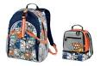You will need to purchase a **lunch box and regular sized backpack without wheels** for your child. FOLDERS will be provided by the teacher at the start of school, but, then, you will have to replenish the folders with the same colors but vinyl because they are more durable. (**supplies need to be replenished – supply list will follow from the teacher**).

**VISIT OUR SCHOOL’S WEBSITE FOR THE COMPLETE SUPPLY LIST:** [**www.wpschools.org**](http://www.wpschools.org) **(Charles Olbon School)**



If your child’s day has any **changes**, especially at dismissal, (no bus one day, home with a friend, etc.) **please send a note**. ***We will NOT change the routine without a NOTE from a parent / guardian.***

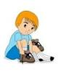Please have the children ready to use the **bathroom** on their own. Help them to dress themselves correctly before coming back into class. Clothing with difficult buttons and snaps force children to leave the bathroom to find help. This is often very embarrassing. Keep this in mind when buying new school clothes. Children need to **practice how to tie shoe laces** on a **daily basis**. *This will be greatly appreciated.*

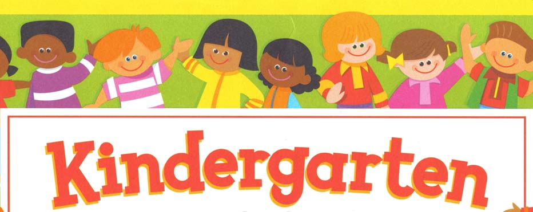



**Ms. Tonti**

**Charles Olbon School**

**Room 4**

**September 2017**

Dear Parents / Guardians,

***Welcome to Charles Olbon School and Kindergarten!*** I am very excited about the school year and have many interesting and educational activities planned for the children. Since this year is your child’s introduction to grammar school, I want it to be a great one. My goal is to get them interested in and excited about learning. I will be teaching them how to be terrific students. If we, parents and teacher, work together, children will appreciate education and learning so much more. This will allow them to grow in to fine young curious learners. The following is a list of useful suggestions and procedures that will make the year smoother for all of us. ***I am thanking you in advance for all your cooperation!***

1. You can follow the kindergarten supply list that has been provided

for your child (**regular sized backpack** is very useful for taking everything home).

1. Always look at their **work** and ask about it.

3. Our class has **gym** on **TUESDAY**. Please make sure your

child wears **sneakers and play clothes** to school on that day. **(*school clothes are only exempt***

***on our PE day*)**

1. Please send in a **healthy snack** each day. Also, provide **ONLY**

**WATER**. Our snack time is about 10:15 am (time subject to change to late afternoon depending on our

class schedule). Candy is *NOT*  permitted.

1. If your child is **assigned to a bus**, but **will not** be taking it

home from school **at all** this year, you must **send a note** to have them **removed from the bus list**.

1. If your child’s **after school schedule changes** at any time,

(even if just for the day), you must **send a note**. Please include the name of the person who will pick

**(*SEE BACK*)**

up your child, if it is not yourself. ***We will******NOT******change a schedule without a note. (If***

***your child is on a bus list, we must put them on the bus unless we have a note).***

1. Any **money sent to school** must be in a **labeled envelope** with

**Mary Smith K-Tonti Lunch**

your child’s name, grade, and subject –what it is for (for example, Mary

Smith K-Tonti Lunch). This is helpful! Also, any cash

must be **exact change**. **Breakfast, and / or lunch money** **must be** **sent in according to the**

**information you received in the mail. *Please follow this procedure accordingly. Thank you!***

1. Please make sure your child can use the **bathroom on his / her**

**own**. They should be able to **dress themselves and clean themselves** before coming out of bathroom. It

is embarrassing for your child to have to leave the bathroom to ask for help with difficult buttons and

snaps.

1. ***Birthdays are special!*** If you would like to send a **sweet *OR* treat**

for the class, please send us a **note stating the day** you will send it in. You can drop it off in the morning

and we will share is at snack time or at the end of the day. ***We can NOT accommodate***

***decorations or drinks.* *The treats must be individual and ready to serve.***  **Party**

**invitations may be given out in class ONLY if the ENTIRE class is invited. *We do not want to hurt***

***anyone’s feelings.* PLEASE BE SURE TO FOLLOW THE SCHOOL’S CELEBRATION**

**PROCEDURES.**

**\*\* GOODS BAKED IN A NUT FREE FACILITY and DAIRY FREE**

1. Last, but not least, please **do not send** your child to school with

**toys** from home, since we **can not be responsible** for them if they are **lost or broken**.

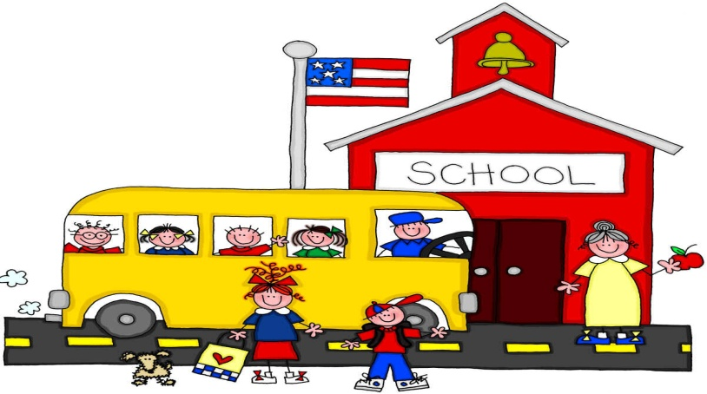Following the above stated procedures will be greatly appreciated. I am looking forward to teaching your child and sharing this special and important year with him/her. Please do not hesitate to contact me with any questions and/or concerns you may have (email [ctonti@wpschools.org](mailto:ctonti@wpschools.org)).

Sincerely, Ms. Tonti

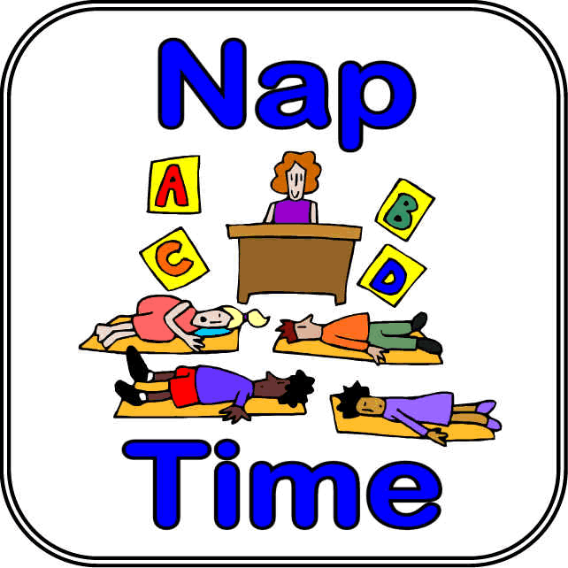September 2017

Dear Parents/Guardians,

Please provide your child with a **blanket**, **towel**, or **mat**, and a **small pillow** they can use during rest time. **Label** the item with your **child’s first and last name** as well as **grade** (*for example, John Smith K-To*). These items will be sent home every Friday to be washed and returned the following Monday. Rest time follows lunch. Rest time duration is longer in the beginning of the year. The time is gradually decreased.

*Thank you for your sincere cooperation and assistance.*

Sincerely,

**Ms. Tonti**

**Ms. Tonti**

**Charles Olbon School**

**Kindergarten**

**Room 4**

September 2017

Dear Parents / Guardians,

 In an effort to understand your child and his or her needs, I would like you to answer the following questions and complete the attached page. These questions and fill-ins will help me become better acquainted with your child and help me when I am teaching him or her daily. Open communication between parents and teachers is the key to a successful kindergarten experience. This is just one of the ways I can incorporate your feedback into your child’s education. As always, your cooperation is greatly appreciated. I am looking forward to reading about your child.

Sincerely,

Ms. Tonti

Parent’s / Guardian’s Name(s) - __________________________________________________

Child’s Name - _______________________________________

What would you like me to know about your child that will help me provide a nurturing learning environment?

What would you like your child to gain from kindergarten?

**SEE BACK**

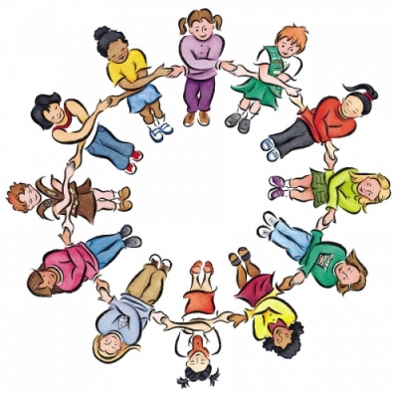ALL ABOUT “ME”

What is your name? _________________________

Do you have a nickname? _____________________

How old are you? ________

Do you have a brother(s)? _____________________________________________________

Do you have a sister(s)? _____________________________________________________

Do you have a pet(s)? _____________________________________________________

“MY” FAVORITES

What is your favorite snack? ______________________________

What is your favorite food (meal)? __________________________

What is your favorite color? _______________________________

What is your favorite book? _______________________________

What is your favorite game? _______________________________

What is your favorite sport? ______________________________

What is your favorite show? _______________________________

What is your favorite movie? ______________________________

Is there anything else you would like your teacher to know about you? _____________________________________________________

Please take a few moments to complete this questionnaire.

Return to school no later than **September 13th**

Thank you.

Child’s name_________________________________________________________

Names and ages of brothers/sisters________________________________________

Language first spoken by the child__________________________________________

Language child uses most often____________________________________________

If you have an e-mail address, and would like to provide it to me as a means of

teacher/parent communication, please print neatly below

_________________________@________________________

This e-mail address belongs to___________________________________________

***Please circle the response that best applies:***

1. How does your child feel about coming to kindergarten?

excited nervous scared

2. What term best describes your child?

outgoing energetic timid shy

3. My child has participated in these activities (circle all that apply):

preschool - Name of school:______________________________________

in-home child care play groups organized sports

creative activities (such as dance or music)

4. My child enjoys these activities (circle up to four):

looking at books using computer playing with puzzles

watching television building with blocks imaginative play playing outside listening to stories coloring

5. My child will ask for help when needed

often sometimes seldom/never

6. Someone reads to my child

often sometimes seldom/never

7. My child stays interested in self-chosen activities for

5-10 minutes. 10-20 minutes. 20-30 minutes.

**PLEASE TURN OVER>>>>>>>>**

8. My child takes care of bathroom needs independently

often sometimes seldom/never

9. My child plays with other children often sometimes seldom/never

Age of children younger same age older

10. Does your child have a favorite activity?

____________________________________________________________________________________________________________________________________________________________________________________________________________________________________________________________________________

11. Does your child have access to a computer at home? yes no

12. Is there additional information that you would like to share with me about your child.

yes no

Additional information:

________________________________________________________________________________________________________________________________________________________________________________________________________________________________________________________________________________________________________________________________________________________________________________________________________________________________________________________________________________________________________________________________________________________



September 2017

Dear Parents / Guardians,

The following is an outline of the different folders your child will be bringing home. I have color coded them to make things a little less confusing for you, your child, and yes, me, too!

** 1. The **NOTICES** folder is **YELLOW**: Check this folder ***DAILY*** for important

notices that will be sent home with your child. Please include any notes you may have for me and / or another staff member and for the office.

** 2. The **HOMEWORK** folder is **GREEN**: The **LEFT** side of this folder will include any and all daily homework assignments. Please have your child complete any and all homework on their own. If they are having any difficulties with their homework assignment(s), please do not assist them, just write me a note and I will help them. Once your child has completed the homework assignment(s), please check, *sign*, and place it in the correct folder to be *returned the following school day or on the due date*. The **RIGHT** side of this folder should contain completed assignment(s) that I will collect and return to your child. ***This folder along with all others should always remain neat and organized to help your child learn how to be organized and responsible.***

3. The **ASSESSMENTS** folder is **RED**: Review any evaluations sent home with your child, sign your *signature and date* the *highlighted area* on the cover sheet (NOT on the folder), and **return folder and ALL papers** with your child the *very next school day*. *If you are planning to provide a further review for your child and would like to hold on to this folder and these papers for an extra day or two, please write me a note and place it in the* ***YELLOW*** *folder.* **You will only receive this folder about once a month.**

4. The **WRITING WORKSHOP** folder is **BLUE**. This will include any writing assignments (for example, picture stories) that have been completed in class. ***Please read your child’s work for they take great pride in their work!*** Sign your *signature and date* the *highlighted area* on the cover sheet (NOT on the folder), and **return folder and ALL papers** with your child the *very next school day*. **You will only receive this folder about once a month, at the end of the month.**

** 5. The **CLASSWORK** folder is **BLACK**. This folder will contain ***incomplete*** and ***completed*** class work assignments as well as any checked homework assignments. Please clean out the ***RED SIDE = STOP, COMPLETED*** ***WORK*** *DAILY*. These papers may remain at home. Please *do NOT* remove papers on the ***GREEN SIDE = GO, KEEP WORKING - INCOMPLETE WORK***. These papers need to be completed. Once completed, the work will be moved to the RED SIDE and then, can remain at home.

6. The **CENTERS** folder is **ORANGE**. This folder is only for in-class purposes. It will not be sent home. The folder will contain work that may be completed and / or not completed from center time (learning stations promote an on-going learning of material that has been fully presented to your child). Once, the stations have been completed all work will be placed in the ***BLACK*** folder, on the ***RED SIDE***, to take home and leave home.

*\*\** ***THE FOLLOWING FOLDERS: #s 1, 2, and 5***

***MUST BE RETURNED ON A DAILY BASIS.***

** **For FOLDERS (#s 4, 5, and 6), you will see a GREEN dot and a RED dot. The side marked with a GREEN dot means that the work located in this pocket is NOT completed (green = go = keep working). The side marked with a RED dot means that the work located in this pocket is COMPLETED (red = stop = work is completed).**

**NOTE:** I will be helping your child for the first few months of school with this system. Please help them at home, as well, until they feel comfortable with this procedure. Complete and detach below the dotted line, place it in the ***YELLOW NOTICE FOLDER***, and ***return*** the following school day or as soon as you have read the memo fully. Keep the first page for your home records.

***Thank you for your sincere assistance and cooperation in making this a successful transition for your child, my student!***

Sincerely,

Ms. Tonti

**………………………………………………………………………………………………………**



**_________** I have read and understand the Color Coded Folder System.

_________ I have the following question(s) regarding this system.

____________________________________________________________

____________________________________________________________

____________________________________________________________

____________________________________________________________

**Your Child’s Full Name: (PLEASE PRINT) _______________________________**

** Parent/Guardian Signature:**

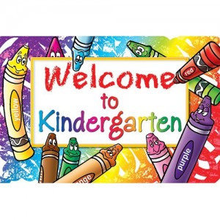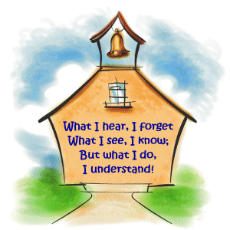**Charles Olbon School**

**Ms. Tonti**

**Kindergarten**

**Room 4**

**2017-2018**

**Classroom Procedures / Subject Overview**

**Morning Routine:**

**Attendance Calendar Review** (date, days of the week, months of the year)

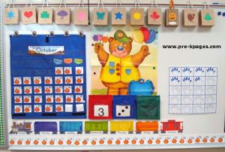**Folders Seasons**

**Snack & Lunch Check Weather**

**Pledge ABC song / Letter(s) songs**

**Patriotic Song**

**Language Arts (Phonics, Reading, & Writing):** Three periods per day.

**Letter & Sound** of the week (Aa to Zz)

**Poems/Books** related to that Letter

****Complete **Letter Work** related to the letter & concept of the week (following directions, using pictures, picture & story sequencing, and cause & effect)

**Handwriting** (heading – name, grade, and date; letters; words; and sentences)

**Sight Word(s)** of the week (+ review of past words) (find, read, spell, read, sentence)

**Decodable Words** (sounding out words with familiar sounds – sounds that were and are being taught)

+ Weekly **Rhyme Books** (*“Star” Books*) contain decodable words

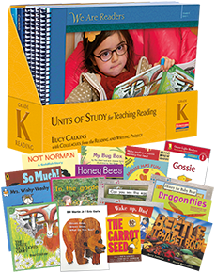

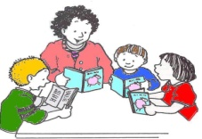**Reading**: *Teacher* models and demonstrates the process of reading,

*Shared Reading* – teacher and student share the process,

***Guided Reading*** – students apply the reading process in small groups / teacher

monitors their reading skills

***Reading Workshop*** – students apply reading skills individually or with partners

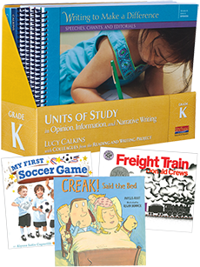

**Writing Workshop** (pictures, letters, words, sentences, mini-stories).



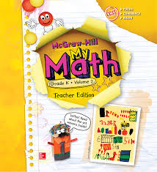

**Math:** Double periods – 1. Introduce skill / concept (model) 2. and Development of skill / concept (hands – on) and evaluation (workbook pages)

**Colors**

**Shapes**

**Position Words** (top, middle, bottom, above, below, left, right, etc.)

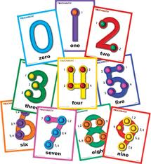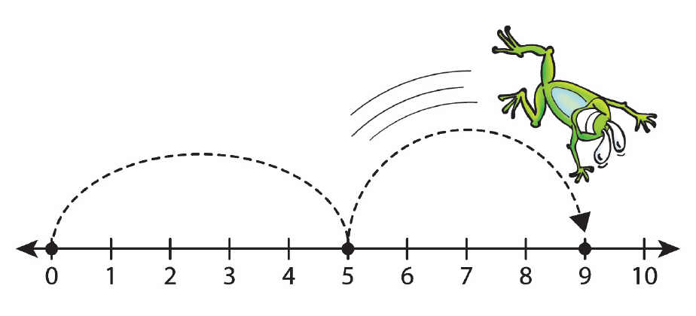**Classification** (**Grouping** based on attributes: colors, sizes, shapes, physical appearances, characteristics/traits, etc.)

**Graphing** (bar graph and picture graph)

**Numbers** (counting, writing, identifying, applying)

**Counting by 2s, 5s, 10s**

**Addition**

**Subtraction**

**Problem Solving** (Word Problems)



**\*\*\*\* THE FOLLOWING SUBJECTS TAKE PLACE ONCE A WEEK…**

**SCHOLASTIC NEWSPAPERS MAY ALSO BE IMPLEMENTED**

**FOR THE FOLLOWING**

**Social Studies:** Introduced by teacher with a reading or explanation and developed through hands – on activities or projects

**Seasonal** and **Monthly Events** and **Holidays**

***Social Studies McGraw Hill Program will continue for 2017-2018***

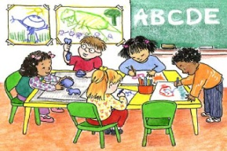**Science / Health:** Introduced by teacher with a reading or explanation and developed through hands – on activities or projects

**Seasons Plants Self & Family Healthy Habits**

**Weather Animals Feelings Nutrition**

**Seasonal** and **Monthly Events** and **Holidays**

***Sciene Pearson Program will begin for 2017-2018***

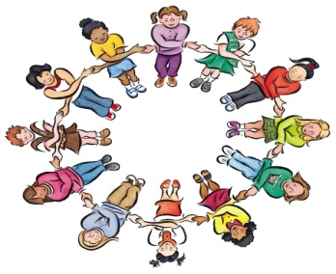**Character Education:** Introduced by teacher with a reading or explanation and developed through hands – on activities or projects

**Citizenship**

**Positive Student and Individual Characteristics**

**Rules**

**Seasonal** and **Monthly Events** and **Holidays**

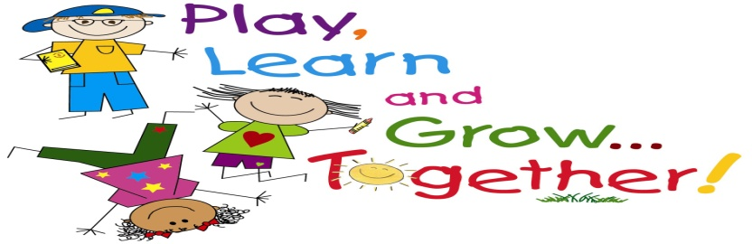**Centers:** Centers reinforce skills and concepts that were taught and are being taught. These are designed to allow students to further progress on these skills and concepts. Teacher introduces each center gradually. There are 6 to 8 stations opened at a time, with a maximum of four (4) students per center. The following is a list of ***some***, not all, *available center topics*:

**Matching Alphabet Pairs** (Capital and Lower Case Letters)

**Letter Identification**

**Sound Identification** (Initial, Medial, & Final Sounds of Vowels & Consonant Letters)

**Sight Word Identification**

**Building Decodable Words**

**Writing Simple Sentences**

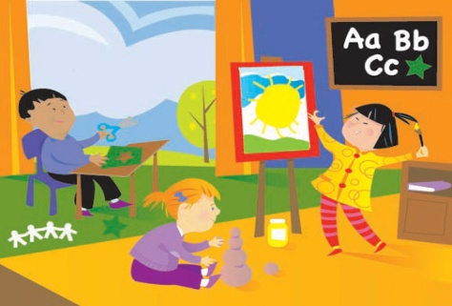**Matching Shapes**

**Sorting**

**Graphing**

**Estimating**

**Addition and Subtraction Stories**

**Seasonal/Holidays**

**\*\*\*\* Routines are subject to change depending on special school programs, weather, etc.**



**Homework:**

**Assist with Directions ONLY**

**Sign & Return *by due date*** **(or if no due date appears, *return the next school day*)**

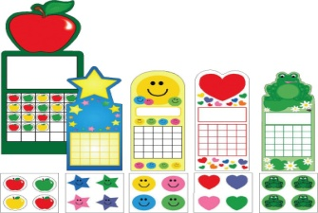**Do NOT allow your child to become overly frustrated with homework** **– *STOP* – *WRITE A NOTE* – *PLACE HOMEWORK & NOTE IN THE GREEN FOLDER*** (*Please, I kindly ask that you do not use this policy as an excuse.*)



**Motivational Incentive:**

**Individual Sticker Chart** – stamps are only earned NEVER removed – earned by *good behavior* (following school and class rules, following directions, etc.), *classwork completion and participation*, and *homework completion* (or effort) – when the chart is filled with stamps, the child takes “a trip” to the **“*treasure chest*”** – may also go to the “treasure chest” for *challenge questions and answers*.

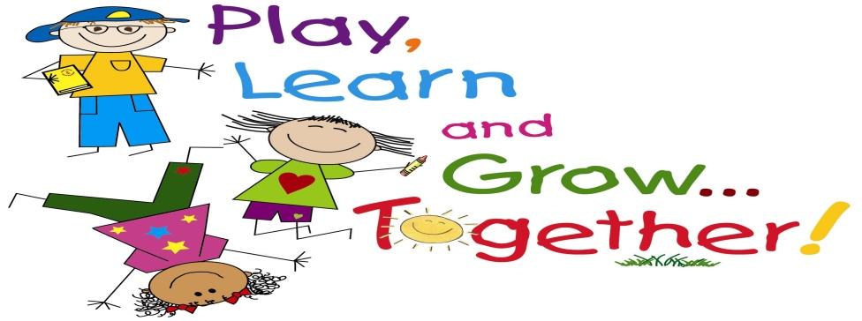

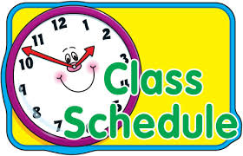Charles Olbon School

Class Schedule 2017-2018

Kindergarten – Ms. Tonti (K – To)

|  |  |  |  |  |  |
| --- | --- | --- | --- | --- | --- |
|  | Monday | Tuesday | Wednesday | Thursday | Friday |
| **8:52-9:05** | Homeroom / Morning Meeting | | | | |
| **Period 1**  **9:05-9:52** | ELA  Fundations | ELA  Fundations | ELA  Fundations | ELA  Fundations | ELA  Fundations |
| **Period 2**  **9:54-10:39** | ELA  Reading | ELA  Reading | ELA  Reading | ELA  Reading | ELA  Reading |
| **Period 3**  **10:41-11:26** | ELA  Writing | PHYSICAL  EDUCATION  **PLC TIME | ELA  Writing | ELA  Writing | ELA  Writing |
| **Period 4**  **11:28-12:13**  **\*11:28-12:15\***  **\*KDG Lunch\*** | LUNCH | LUNCH | LUNCH | LUNCH | LUNCH |
| **Period 5**  **12:17-1:02** | Math | ELA  Writing | Math | ART  (in classroom) | Math |
| **Period 6**  **1:06-1:51** | Math | Math | Math | Math | Math |
| **Period 7**  **1:53-2:38** | WORLD  LANGUAGE  (in classroom) | Math | MUSIC | Social Studies | COMPUTERS |
| **Period 8**  **2:40-3:25** | Science | Science | Science  /  Health | MUSIC | Social Studies  /  Character Education |
| **3:25-3:28** | Homeroom / Dismissal | | | | |

2017-2018 Special Classes Schedule for K-Tonti



**World Language**with **Senora Monaghan** on **Monday**

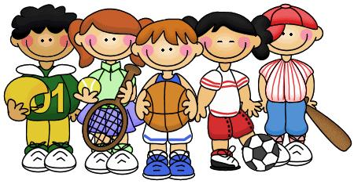



**Physical Education with Mr. Scholtz on Tuesday**

**Remember to wear your SNEAKERS and NO JEWELRY on this day.**



**Music with Mrs. Beirne on Wednesday and Thursday**





**Art with Mrs. Toole is on Thursday**





**Computers with Ms. McGinnis on Friday**

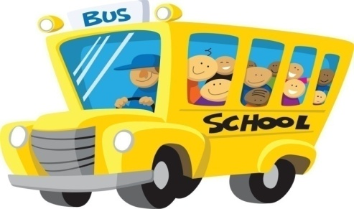**UPDATED SEPTEMBER 2017**

**Ms. Tonti’s Class Roster**

**Charles Olbon School**

**Kindergarten (2017-2018)**

**Ms. Tonti – Classroom Teacher**

|  |  |
| --- | --- |
| **Andjela (G)** | **Luzabella (G)** |
| **Brooke (G)** | **Madelyn (G)** |
| **Christopher (B)** | **Mahila (G)** |
| **Dante (B)** | **Mohamed (B)** |
| **Dylan (B)** | **Nedim (B)** |
| **Emiliano (B)** | **Rafely (B)** |
| **Giovi (B)** | **Rital (G)** |
| **Grace (G)** | **Sarah (G)** |
| **Juliana (G)** | **Sofia (G)** |
| **Liliana (G)** | **Yusuf (B)** |

**Total = 20 (9 Boys / 11 Girls)**

C:\Users\Claudia\AppData\Local\Microsoft\Windows\Temporary Internet Files\Content.IE5\ORM42CSN\MCj02920860000[1].wmf

**Ms. Tonti**

**Charles Olbon School**

**Kindergarten**

**Room 4**

September 2017

Dear Parents/Guardians,

Homework reinforces lessons taught in the classroom. Kindergarteners are unable to read the directions (located at the top or bottom of the page(s)). Therefore, the children rely on the adults to read the directions to them.

Parents/Guardians are not to complete the child’s homework. However, **parents/guardians must read the directions to the child and check that it is being fully completed and completed correctly**. Then, **parental/guardian signature is required**.Yes, the children are gaining independence, but, nonetheless, they are still just kindergarteners.

*Thank you for your sincere cooperation and assistance!*

Sincerely,

Ms. Tonti

**\*\*\*\*Please sign and return one copy the next school day and keep one copy for your records.**

**C:\Users\Claudia\AppData\Local\Microsoft\Windows\Temporary Internet Files\Content.IE5\F14L65ZS\MCj02920840000[1].wmf**

C:\Users\Claudia\AppData\Local\Microsoft\Windows\Temporary Internet Files\Content.IE5\ORM42CSN\MCj02920860000[1].wmf

**Ms. Tonti**

**Charles Olbon School**

**Kindergarten**

**Room 4**

September 2017

Dear Parents/Guardians,

Homework reinforces lessons taught in the classroom. Kindergarteners are unable to read the directions (located at the top or bottom of the page(s)). Therefore, the children rely on the adults to read the directions to them.

Parents/Guardians are not to complete the child’s homework. However, **parents/guardians must read the directions to the child and check that it is being fully completed and completed correctly**. Then, **parental/guardian signature is required**.Yes, the children are gaining independence, but, nonetheless, they are still just kindergarteners.

*Thank you for your sincere cooperation and assistance!*

Sincerely,

Ms. Tonti

**\*\*\*\*Please sign and return the next school day.**

**C:\Users\Claudia\AppData\Local\Microsoft\Windows\Temporary Internet Files\Content.IE5\F14L65ZS\MCj02920840000[1].wmfParent/Guardian Signature:**

2017-2018

Dear Parents/Guardians,

The following should be implemented on all assignments:

1. your child needs to write his/her ***HEADING*** at the top, unless otherwise directed,
2. all written and drawn work must be completed using a ***PENCIL*** (*writing and/or drawing in pen, marker, crayon, or colored pencils is not permitted*-this tends to make work look less neater),
3. all work that requires coloring must be completed with ***CRAYONS and/or COLORED PENCILS*** (*markers are not permitted* because they tend to bleed through the paper and can make work look messy),
4. a ***Parent/Guardian SIGNATURE*** is required on *ALL* assignments,
5. and work is to be ***RETURNED*** on ***DUE DATES*** (If no school due to sickness or weather, then the very next day or upon return to school).

I ask you to please monitor homework assignments daily. Yes, students are

to complete their own work, but, parental guidance is needed. We need to set a positive example starting at an early age. Together, we can help our children achieve greater good by following basic procedures.

***Thank you for your continuous support and cooperation on this subject matter.***

***Sincerely,* Ms. Tonti**

**Cut and Return the Bottom Portion -----------------------------------------------------------------------------**

2017-2018

Dear Parents/Guardians,

The following should be implemented on all assignments:

1. your child needs to write his/her ***HEADING*** at the top, unless otherwise directed,
2. all written and drawn work must be completed using a ***PENCIL*** (*writing and/or drawing in pen, marker, crayon, or colored pencils is not permitted*-this tends to make work look less neater),
3. all work that requires coloring must be completed with ***CRAYONS and/or COLORED PENCILS*** (*markers are not permitted* because they tend to bleed through the paper and can make work look messy),
4. a ***Parent/Guardian SIGNATURE*** is required on *ALL* assignments,
5. and work is to be ***RETURNED*** on ***DUE DATES*** (If no school due to sickness or weather, then the very next day or upon return to school).

I ask you to please monitor homework assignments daily. Yes, students are

to complete their own work, but, parental guidance is needed. We need to set a positive example starting at an early age. Together, we can help our children achieve greater good by following basic procedures.

***Thank you for your continuous support and cooperation on this subject matter.***

***Sincerely,* Ms. Tonti**

**Parent/Guardian Signature:**

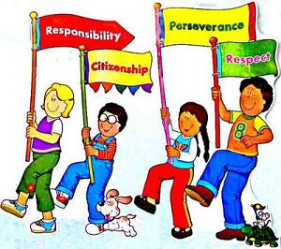

2017-2018

Dear Parents/Guardians,

We need to show our children how important school is. The students can only learn this important concept through modeling. I, alone, can not complete this task. Parents, I need your help!

We need to model responsibility. We need to model how to follow procedures and directions. Complying with **due dates**, for assignments and / or projects, is necessary. **Returning assignments and / or projects and books** to school are also significant. We have to remember that our children are only kindergarteners. Therefore, they need our attention and guidance.

If the adults are not following procedures and directions, we are teaching our children to do the same. Kindergarten is a critical year for your children to learn the behaviors which will assist your children throughout their school career.

We must work together to make this a productive school year. **Remember to follow procedures accordingly and follow directions so that your child is prepared and ready for the school day ahead**. Children are vulnerable and look at us, the adults, for proper guidance.

*Thank you for your sincere cooperation and assistance!*

Sincerely,

**Ms. Tonti**

* **1. HELP with HOMEWORK (e.g. read and follow directions)**
* **2. SIGN and RETURN any and all work that is STAMPED or in the RED and/or BLUE FOLDERS**
* **3. RETURN sight words, leveled reading, and library BOOKS the next school day, or for library books, return on the due date.**
* **4. RETURN NOTICES quickly and on – time**

**Please sign and return the first (1st) copy the next school day. Keep the second (2nd) copy for your home records.**



2017-2018

Dear Parents/Guardians,

We need to show our children how important school is. The students can only learn this important concept through modeling. I, alone, can not complete this task. Parents, I need your help!

We need to model responsibility. We need to model how to follow procedures and directions. Complying with **due dates**, for assignments and / or projects, is necessary. **Returning assignments and / or projects and books** to school are also significant. We have to remember that our children are only kindergarteners. Therefore, they need our attention and guidance.

If the adults are not following procedures and directions, we are teaching our children to do the same. Kindergarten is a critical year for your children to learn the behaviors which will assist your children throughout their school career.

We must work together to make this a productive school year. **Remember to follow procedures accordingly and follow directions so that your child is prepared and ready for the school day ahead**. Children are vulnerable and look at us, the adults, for proper guidance.

*Thank you for your sincere cooperation and assistance!*

Sincerely,

**Ms. Tonti**

* **1. HELP with HOMEWORK (e.g. read and follow directions)**
* **2. SIGN and RETURN any and all work that is STAMPED or in the RED and/or BLUE FOLDERS**
* **3. RETURN sight words, leveled reading, and library BOOKS the next school day, or for library books, return on the due date.**
* **4. RETURN NOTICES quickly and on – time**

**Please sign and return the first (1st) copy the next school day. Keep the second (2nd) copy for your home records.**

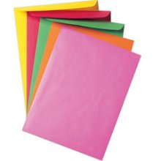2017-2018

Every week your child will learn a **SIGHT WORD(s)**. We will

make **FLASHCARDS** for these words. You will find the

flashcards in an **ENVELOPE**. Your child must **STUDY**

these words **DAILY** (everyday). Keep **ALL FLASHCARDS**

in the **ENVELOPE**. Keep the envelope containing the words in

the **YELLOW FOLDER** until your child receives a *Reading*

*Bag* later in the school year. **RETURN DAILY** to school.

***Thank you in advance for your cooperation, assistance, and support!***

***Ms. Tonti***

2017-2018

Every week your child will learn a **SIGHT WORD(s)**. We will

make **FLASHCARDS** for these words. You will find the

flashcards in an **ENVELOPE**. Your child must **STUDY**

these words **DAILY** (everyday). Keep **ALL FLASHCARDS**

in the **ENVELOPE**. Keep the envelope containing the words in

the **YELLOW FOLDER** until your child receives a *Reading*

*Bag* later in the school year. **RETURN DAILY** to school.

***Thank you in advance for your cooperation, assistance, and support!***

***Ms. Tonti***

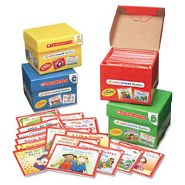

2017-2018

Parents/Guardians,

A **PRE-DECODABLE and / or DECODABLE BOOK(S)** will be sent home ***WEEKLY***. It will be located in a **Plastic Ziploc Bag** labeled with your child’s name.

Practice **READING** with your child **DAILY**. ***READING IS IMPORTANT!!!!*** Refer to the ***“Strategies” Notices***, located in the plastic bag, to use the same techniques at home as used in the classroom.

**RETURN** **DAILY** in the same**Plastic Ziploc Bag**. Be sure that **ALL CONTENTS** are placed back in *this* bag: **ALL BOOKS**, **SIGHT WORDS IN THE ENVELOPE**, **THIS MEMO**, **“STRATEGIES” NOTICE**, and

**PARENT/GUARDIAN SIGNATURE SHEET**.

***PLEASE BE SURE TO FOLLOW ANY AND ALL CLASSROOM PROCEDURES LIKE THE ONE ABOVE. If these ARE FOLLOWED, your child WILL BE PREPARED for school. This helps develop POSITIVE ESTEEM AND / OR CONFIDENCE. PLEASE SUPPORT YOUR CHILD’S EDUCATIONAL SUCCESS.***

***THANK YOU FOR YOUR CONSTANT AND CONTINUOUS COOPERATION!*** Ms. Tonti

***Language Arts Strategies***

***Reading* Tips:**



**1. Use “READING” FINGER (LEFT Pointer**

**Finger) to follow along and stay in place**

**2. LOOK at the Words**

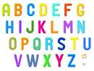**3. THINK of LETTER NAMES**

**4. THINK of the SOUNDS the letters make**

**5. SAY the SOUNDS – Use a METHOD that is**

**COMFORTABLE (EASY) for you**

** Pointer Finger = Beginning Sound**

**Middle Finger = Middle Sound**

**Ring Finger = Ending Sound**

**OR**

** Sound out with your BODY**

**Head = Beginning Sound**

**Belly = Middle Sound**

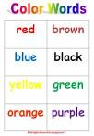**Knees (or Lap) = Ending Sound**

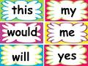**6. Some Words CAN NOT be sounded out (tapped out) (for**

**example, some number words or color words or sight words) –**

**Get your mouth ready to SAY the FIRST couple of**

**SOUNDS (for example, *OR*ANGE)**

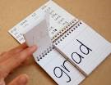 **Constant PRACTICE Needed for such words**

**7. Look for CHUNKS (for example, *Sat*urday)**

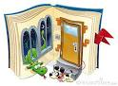**8. Use PICTURES 9. Ask Comprehension Questions**

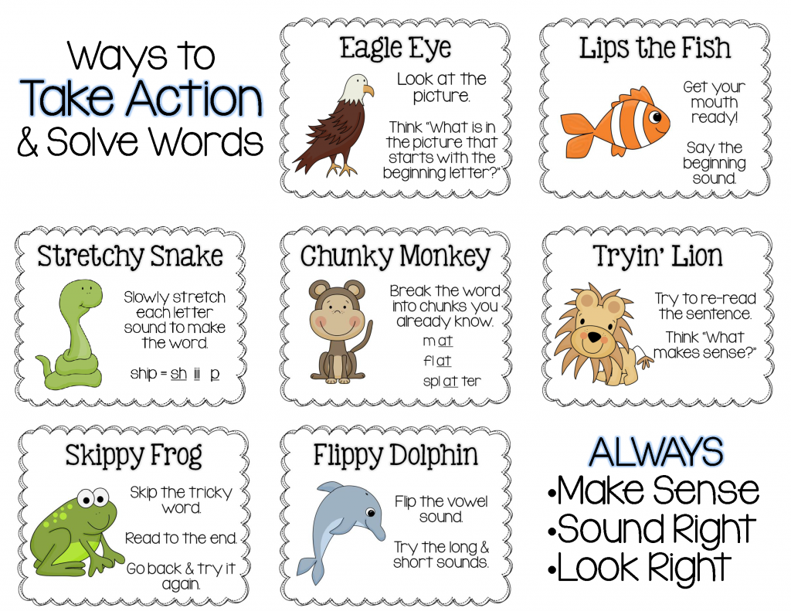

**Some Possible Guided Reading Teaching Points**

**Emergent Reading Strategies**

* Book handling
* Reading top to bottom and left to right
* Tracking print 1:1
* Words on the page make up sentences
* Sentences often describe what happens in the pictures
* Stories have characters, setting, etc.

**Word Attack / Decoding Strategies**

* Look at the picture
* Get your mouth ready to say the word
* Take a running start / Reread the entire sentence
* Skip the word and come back to it
* Look for a chunk
* Think of a word that rhymes

**Self-Monitoring & Self-Correcting Strategies**

* Ask yourself – Does that sound right?
* Ask yourself – Does that look right?
* Ask yourself – Does that make sense?

**Fluency Strategies**

* Reading sounds like talking – not too fast or too slow
* Use inflection – no monotone/robotic voices when reading
* Pausing at punctuation including commas and end marks
* Our voices go up when we read a question
* Change your voice for each character
* Rereading helps with fluency
* Reading and rereading familiar texts helps with fluency

**Comprehension Strategies**

* Taking a picture walk
* Making predictions
* Confirming or denying predictions
* Sequencing/Retelling
* Main Idea / Identifying Important Details
* Character Study
* Problem/Solution
* Making Connections
* Compare and Contrast
* Questioning
* Making mental images
* Author’s Message
* Synthesizing
* Inferring